**Prerequisites:**

**Run command in Terminal:-**

**Sudo systemctl start mongod;**

**Or**

**Sudo mongod**

**In the file module-info.java**

type requires mongo.java.driver;

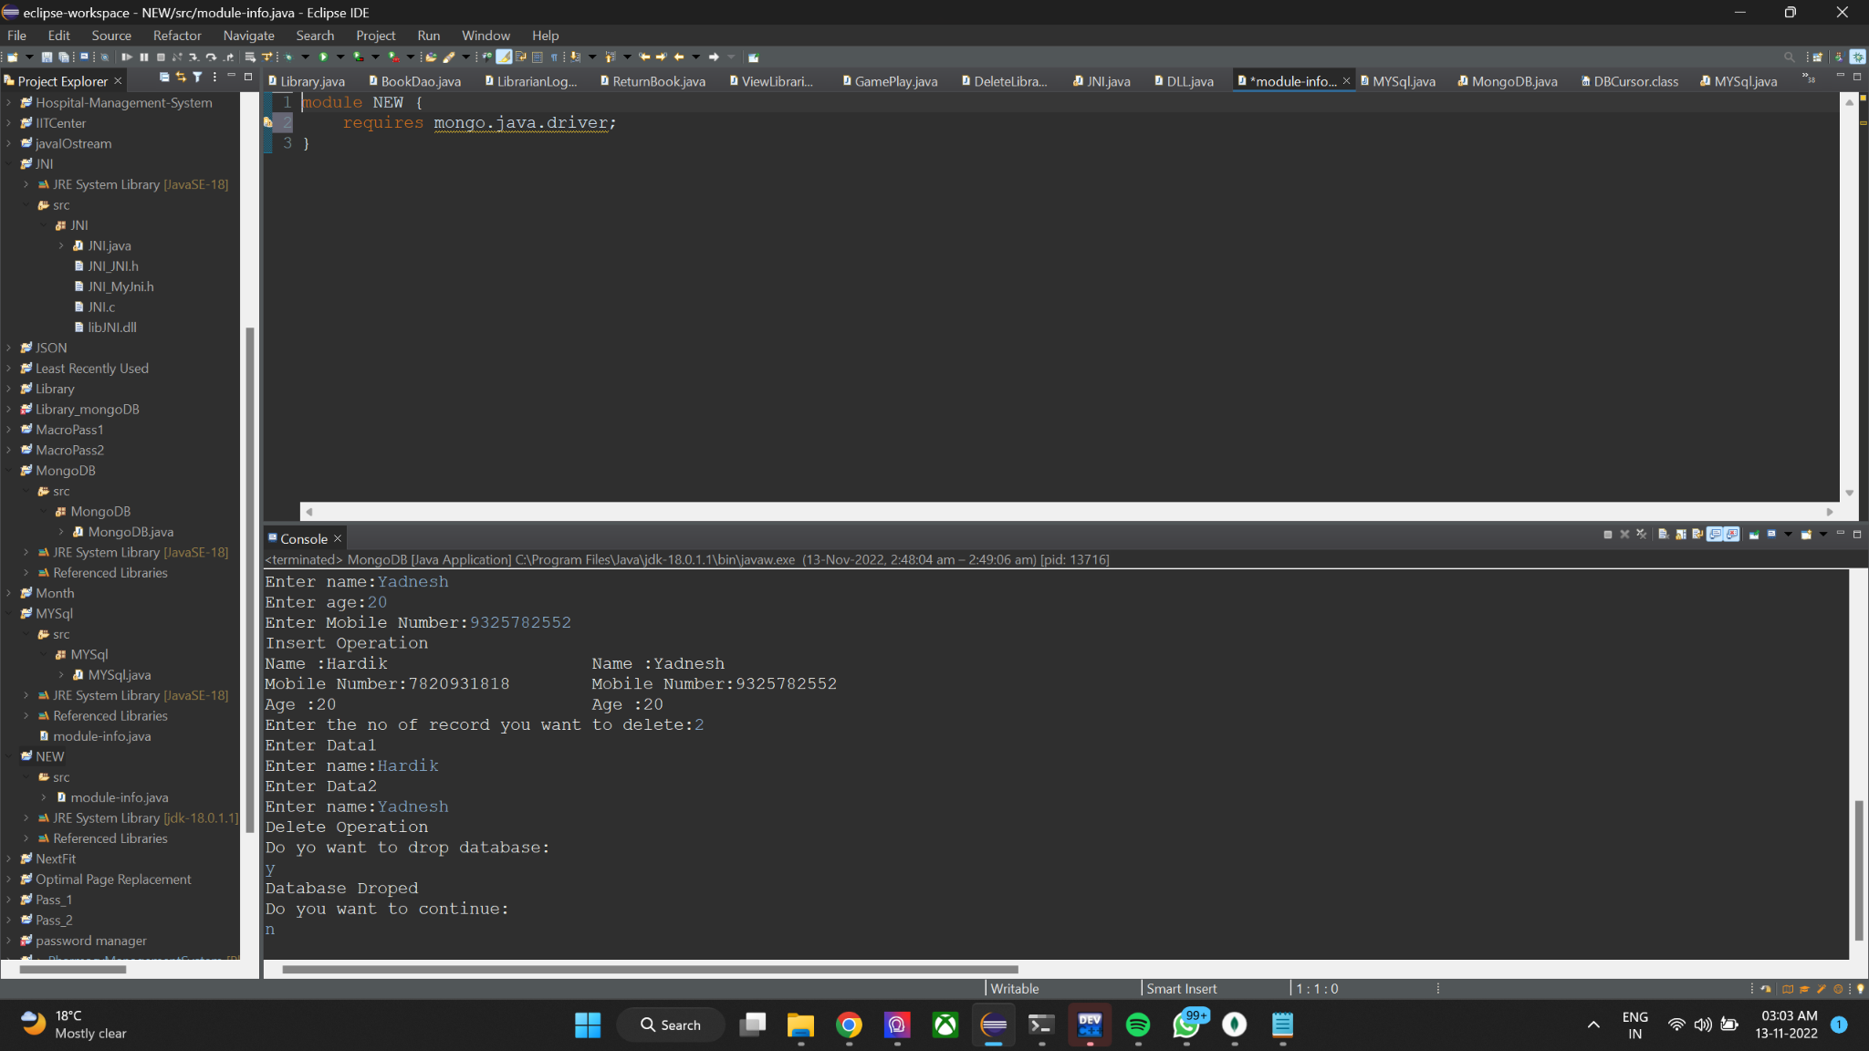

**…………………….....................................C O D E...............................................................**

package MongoDB;

import java.util.Scanner;

import com.mongodb.*;

public class MongoDB {

public static void Stringdata(String data,DBCollection table) {

DBCursor cursor=table.find();

if(cursor.hasNext()) {

while(cursor.hasNext()) {

String Strdata=(String)cursor.next().get(data);

if(data=="Name") {

System.out.print(data+" :"+Strdata+"\t\t\t");

}

else {

System.out.print(data+":"+Strdata+"\t");

}

}

System.out.println(" ");

}

else {

System.out.print("");

}

}

public static void Intdata(String data,DBCollection table) {

DBCursor cursor=table.find();

if(cursor.hasNext()) {

while(cursor.hasNext()) {

int dataint=(Integer)cursor.next().get(data);

System.out.print(data+" :"+dataint+"\t\t\t\t");

}

System.out.println(" ");

}

else {

System.out.print("");

}

}

public static void main(String[] args) throws Exception {

MongoClient mongo=new MongoClient("localhost",27017);

System.out.println("Connected to the database successfully");

Scanner sc=new Scanner(System.in);

int n,age=0;

String name=" ",mobileno=" ",ans=" ",ans1=" ";

do {

DB db=mongo.getDB("Info");

DBCollection table=db.createCollection("Personal",null);

System.out.println("Enter the no of record you want to insert:");

n=sc.nextInt();

for(int i=1;i<=n;i++) {

BasicDBObject info= new BasicDBObject(i);

System.out.println("Enter Data"+(i));

System.out.print("Enter name:");

name=sc.next();

info.put("Name",name);

System.out.print("Enter age:");

age=sc.nextInt();

info.put("Age",age);

System.out.print("Enter Mobile Number:");

mobileno=sc.next();

info.put("Mobile Number",mobileno);

table.insert(info);

}

System.out.println("Insert Operation");

Stringdata("Name", table);

Stringdata("Mobile Number", table);

Intdata("Age", table);

System.out.print("Enter the no of record you want to delete:");

n=sc.nextInt();

for(int i=1;i<=n;i++) {

BasicDBObject info= new BasicDBObject(i);

System.out.println("Enter Data"+(i));

System.out.print("Enter name:");

name=sc.next();

info.put("Name",name);

table.remove(info);

}

System.out.println("Delete Operation");

Stringdata("Name", table);

Stringdata("Mobile Number", table);

Intdata("Age", table);

System.out.println("Do yo want to drop database: ");

ans=sc.next();

if(ans.equals("y")||ans.equals("Y")){

db.dropDatabase();

System.out.println("Database Droped ");

}

System.out.println("Do you want to continue:");

ans1=sc.next();

}while(ans1.equals("y")||ans1.equals("Y"));

}

}

**………………………………………………………………………………………………………………..**

**Step 1: Click on file properties**

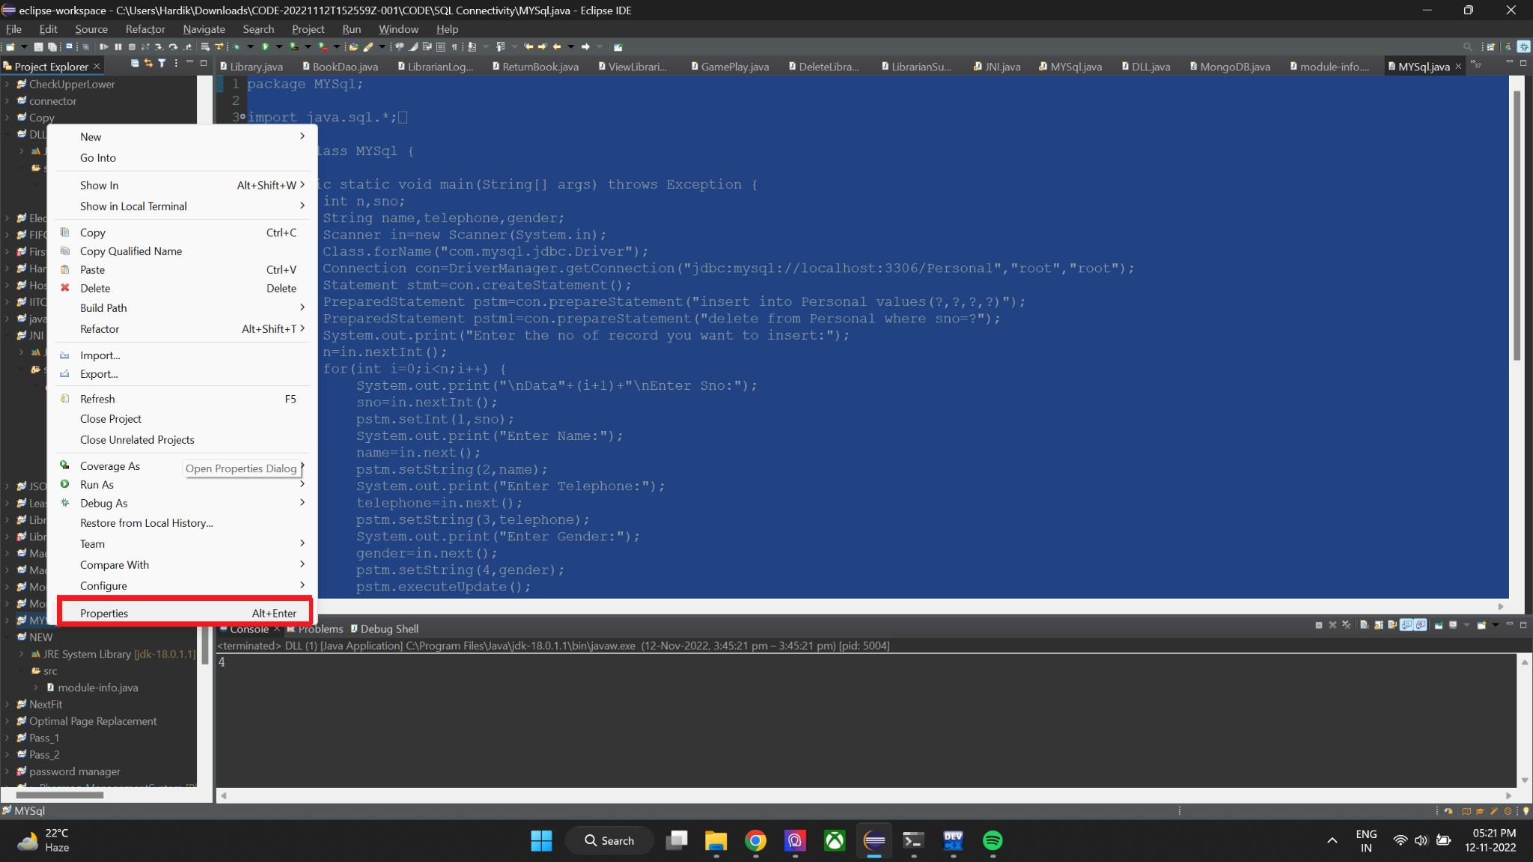

**Step 2: Click on java build path**

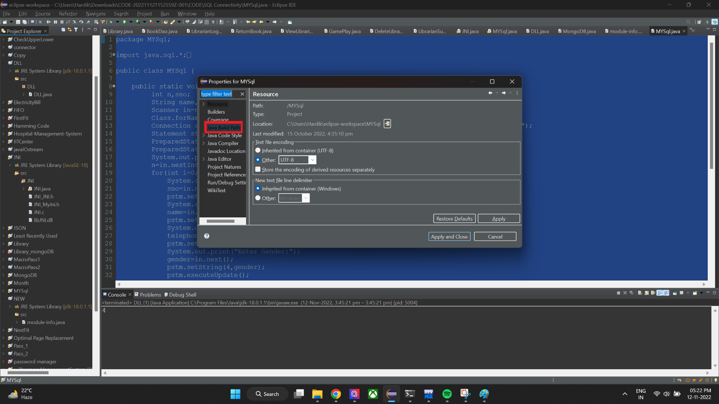

**Step 3: Class path add the external jar file**

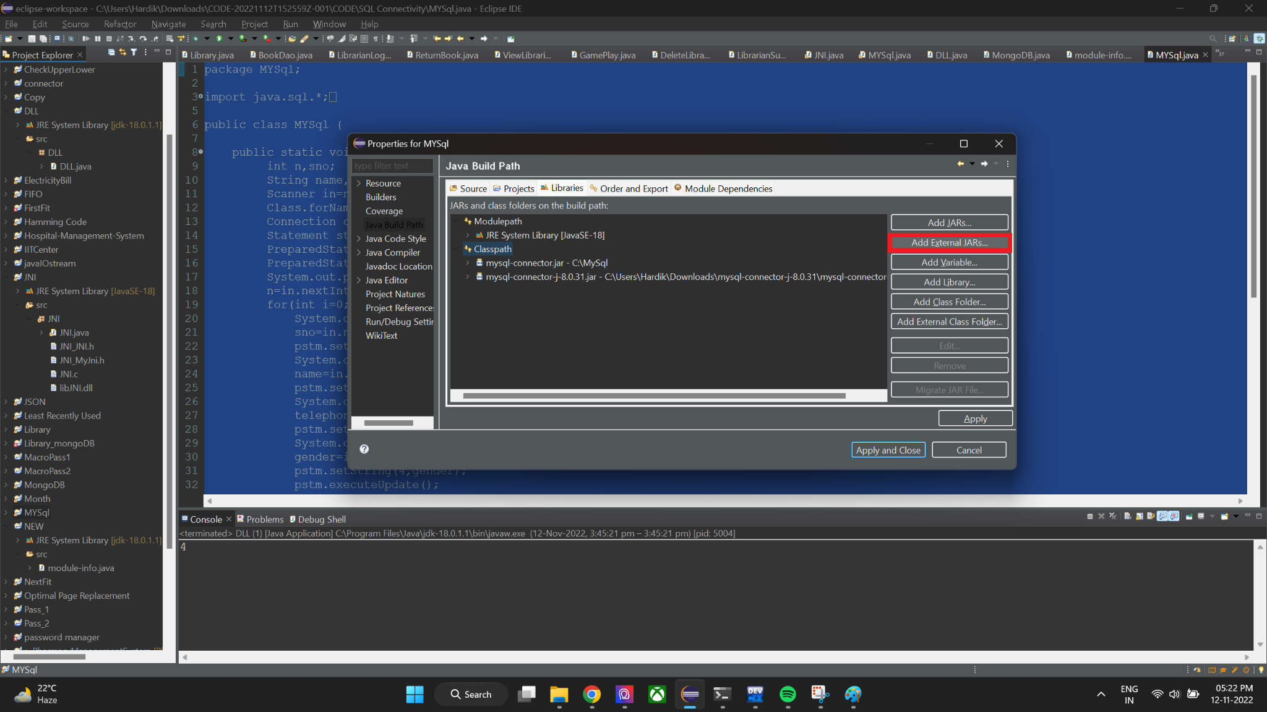

**Step 4: Locate jar file and select it to add it to the classpath**

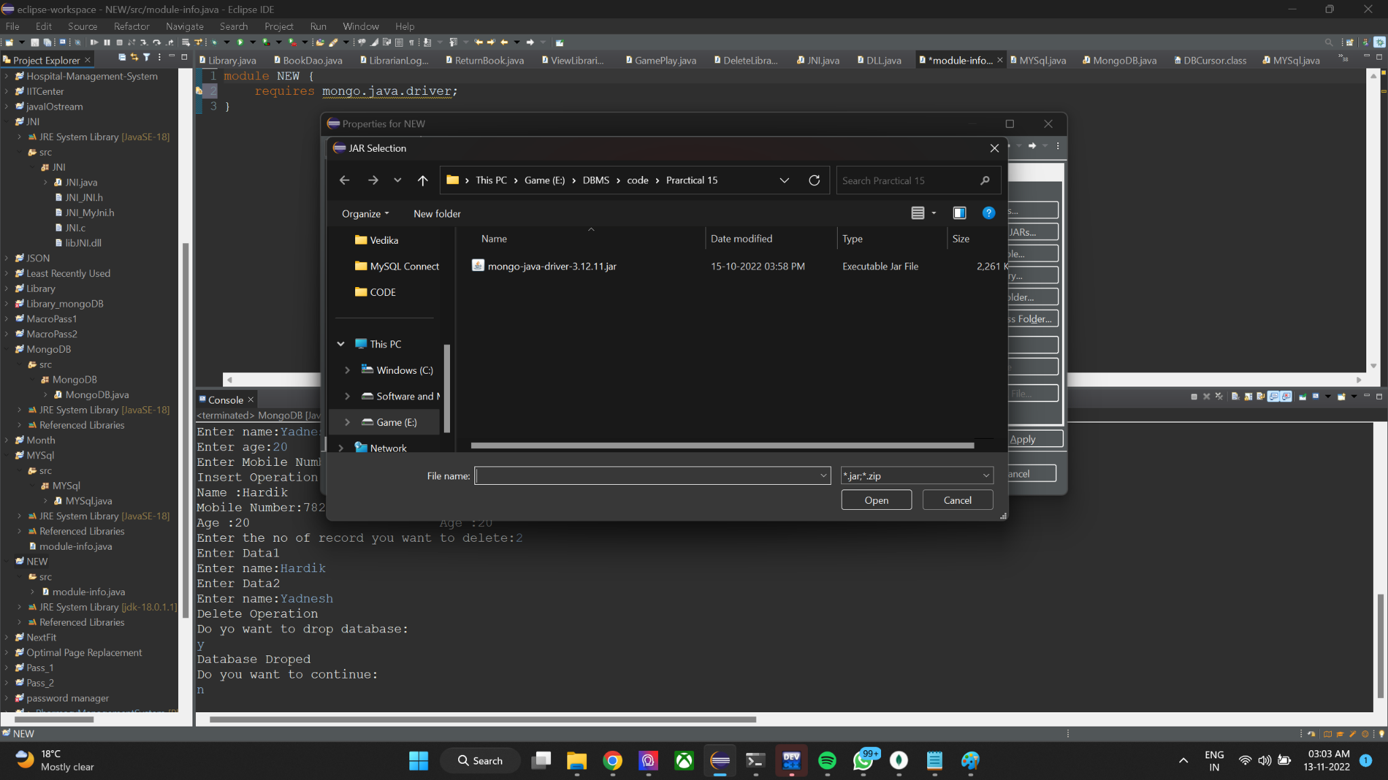

**Step 5: Take the mouse pointer to error then click on move classpath entry**

